2nd Annual Louisiana Pipeliners
Cornhole Tournament
June 23rd Tarpon Pavilion
Grand Isle, Louisiana
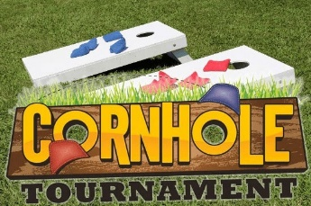

Entry Fee: $50 per Team
Sign up: 6pm to 7pm
Bags Fly at 7pm

All participants must download the Scoreholio app on your phone and create an account.
This is the app that the tournament will be ran on to help speed up the process.

Cash Payout will depend on number of teams signed up. There will be a set of Cornhole Boards also given to 1st and 2nd place winners.
Sponsorships are also available:
$1000 per Company: Company Name announced and on Banner, Rights to Hang Your Company Banners during the Event, and 2-Teams for Tournament.
Please Register on the Louisiana Pipeliners page under the Fishing Tournament Tab.

Please Contact Clay Bercegeay for any questions 225-268-2976

